

Welcome to Air Force Inns at Beale AFB! Whether your stay with us is for leisure or business, we recognize that you have many other hotel options to choose from, and we’re delighted that you’ve chosen us. Please don’t hesitate to give us a call if there is anything we can do to make your stay more enjoyable, simply dial “0” from your room phone to reach the Front Desk.

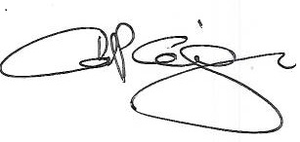  
 Carlos Corsiga, NF-IV  
 Lodging Manager

For lodging, base, and local services and information, please visit our Digital Guestbook



<http://www.myfss.lodgingdigitalguestbook.com>

For a printed copy of our guestbook, please see the front desk.

**If you are experiencing an emergency please dial 911.**

For current information on base activities, such as the fitness center, outdoor recreation, ITT, etc. please visit www.bealefss.com. Also, from here, you can view our current **Lodging Guest Directory**. Just select the “Newcomer or Services” drop down menu, and then select “Gold Country Inn”.



**Gold Country Inn**

**9th Force Support Squadron, Beale AFB, CA 95903**

**DSN: 368-2953, Commercial: (530)634-2953**

***w***elcome to Gold Country Inn, Beale AFB - California. Whether your stay with us for leisure or business, we’re delighted that you’ve chosen the Gold Country Inn.

Should you need any assistance, please make inquiries with any lodging staff members or call our front desk by dialing 0 from your room. Our Front Desk is available 7 days a week, 24 hours a day to assist you.

We hope you enjoy your stay!

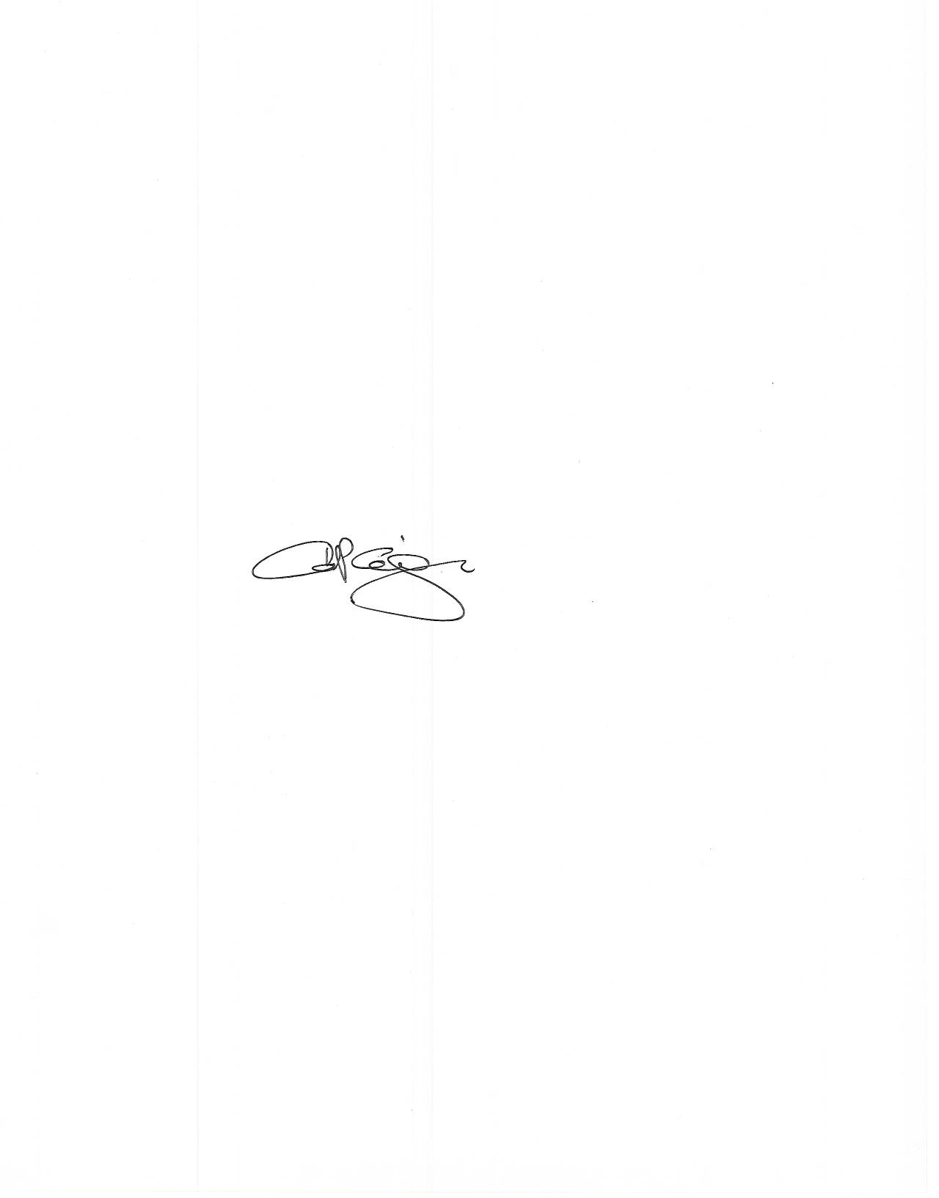

CARLOS P. CORSIGA, NF-IV

Lodging Manager



***Welcome Our Valued Guest!***

*We have provided you with a few complimentary items to get you through your first night’s stay. Feel Free to ask any Lodging team member if you need any of these items replenished. If you forgot to pack any other toiletry item, please visit the front desk. We should have what you need available for purchase.*

***The Air Force Inn’s Promise:***

*“Our Goal is to provide a clean, comfortable room to guarantee a good night’s rest and a pleasant stay. If any part of your stay with us is not satisfactory, please provide the Lodging Manager or Front Desk staff an opportunity to “make it right”.*

**General Information**

**Guest Service Desk**

The Guest Services Desk is located at 24112 A Street and is open 24 hours a day, seven days a week, including holidays. If there is anything you need to make your stay more comfortable, please visit the desk or contact us at (530) 634-2953 or dial 0 from the guestroom phone.

**Payment Methods**

We accept Visa, MasterCard, American Express, personal checks and cash for all purchases and/or payments. Checks may not be written for cash.

**Room Rates**

VAQ (Shared Bathroom) : $74.00

VQ (Private Bathroom) : $89.00

DV Suites : $97.00

Large DV Suites : $97.00

TLF : $96.00

TLF (Pet Friendly) : $96.00 + $10.00 Pet Fee per Night

**Check In and Check Out**

Check in begins at 1400 (2PM) and check out time for all quarters is at 1100 (11AM). A late check out fee (an additional night’s room charge) may be posted to your account after 1100 on the date of your departure. If you have special circumstances and require a late check out, please contact the front desk at (530) 634-2953 or dial 0 from the guest room.

**Service Charges**

***Pets ONLY authorized in designated pet friendly TLF’s.***

Unauthorized Pet in a Room:

- Minimum of $150.00 for deep cleaning

- $10.00 per night for entire stay in room.

Deep Cleaning/Smoking in Room:

Minimum $150.00 cleaning charge, plus any additional cleaning fees and furniture/linen replacement cost if necessary.

Excess Cleaning Fees: Varies case by case.

Fax/Photocopies: No charge (max 10 sheets)

Miscellaneous Service: Varies case by case

Missing/Broken Item: Varies by item replacement and labor costs.

Room/Furniture Damage: Varies by replacement and labor costs.

**Pet Information**

Pet Friendly Contracted Hotels:

* Comfort Suites, Marysville (530)742 - 9200

Pet Friendly Non Contracted Hotels:

* Courtyard Marriott, Roseville (916)722 - 5555
* Residence Inn, Roseville (916)722 - 5500

***\*Many of these hotels will charge an additional nightly fee for pets. Please, check with the hotel for current rates\****

**Pet Boarding Kennels:**

**Marysville Vet Hospital** **Animal Medical Center**

1530 B Street, Marysville-CA 95901 1525 Grass Valley Hwy, Auburn-CA 95603

(530)742-8809 (530)823-5166 (10% Discount for Military)

**Northpointe Vet Hospital** **Mother Lode Vet**

1462 Live Oak Blvd, Yuba City-CA 95991 11509 La Barr Meadows Rd

(530)674-8670 Grass Valley CA 95945, (530)272-6651

**VCA Yuba Sutter Animal Hospital** **Empire Kennels**

1368 Colusa Hwy, Yuba City 95688 11377 Amsel Way, Grass Valley-CA 95945

(530)673-8853 (530)272-6971 (10% Discount for Military)

**Adobe Animal Hospital** **Rocklin Ranch Vet Hospital**

480 N. Palora Ave, Yuba City 95991 2201 Plaza Drive, Rocklin-CA 95765

(530)673-4744 (916)624-7387 (10% Discount for Military)

**Country Vet Clinic** **Family Pet Hospital**

4839 E. Butte Rd, Live Oak-CA 95963 500 Elmira Rd, Vacaville-CA 95687

(530)674-1660 (707)448-1648

***\*There are other boarding kennels available in the local area. Lodging does not endorse any of these pet accommodations. They are provided for information only\****

**Guest Services Information**

**Business Center**:

Located in the lobby of Bldg. 24112 A Street. Our business center is open 24 hours a day, 7 days a week. Our business center contains 2 computers with internet access, CAC card reader and one printer for guest use.

**Fax and Copy service**

Available through the Front Desk 24 hours a day, 7 days a week, copy service is limited to no more than 10 pages.

**Wireless Internet Service**

Lodging offers free wireless internet in all guest rooms and in the main lobby.

*Signal strength may vary based on how many guests are using the system at any given time*

**Laundry:**

Washer and dryers are available in facilities and located as indicated:

* Building 24176B next to room 118B.
* Bldg. 2350 to 2362 located in the hallway of each quad.
* Bldg.5109 to 5116 located in each unit.
* Bldg. 2156 located on the first floor next to room 8.

***\*Coin operated detergent vending machines are located in the central laundry rooms in buildings 2156, 24176, & 2360A\****

**Ice Machines**

Available in all facilities and are located as indicated:

* Bldg. 24176 and 24177 is located in

the laundry room in Bldg.24176.

* Bldg. 2350-2362 are located in the fitness room bldg.2360A and also in all common area freezer (Bldg. 2350 to 2362).
* Bldg.2156 is located in a room next to TV room.
* TLF refrigerator in each unit is equipped with ice maker

**Fitness Room**:

Cardio equipment (Treadmill, elliptical & cycling machines) is available in the VQ quad inside Bldg.2360A.

**Lost and Found Items**:

Please call the front desk at (530) 634-2953 or press 0 from the guest room to retrieve lost items & to report any items left behind in guest room. ID cards and line badges are immediately turned in to Security Forces.

**Mail Services**:

For your postal needs please call the United States Postal Service Center located on main base at (530) 788 – 2401 to set up a temporary postal box.

**Wake up Call Service**:

Please, dial 6000 from your room phone and follow the prompt to set a wakeup call and you can also call Front desk and they will provide a wakeup call per your request. Alarm clocks are also provided in every room for your convenience.

**Maintenance**:

Lodging and Civil Engineering strive to maintain the highest standards of maintenance in all our facilities & guest quarters. If you have any problem that requires repair or maintenance to be performed, please notify the Front Desk. You may also complete the maintenance card provided in your room. Leave the card on the desk or table, and our staff will collect it and begin the repair process.

**Guest Services Information**

**DV Suites Sundry**:

Rooms that have been stocked with resale items such as sodas, wines, liquors & waters are replenished on a daily basis, unless there is a ‘Do Not Disturb (DND)’ or ‘No Service” sign on the door.

**Sundry Items:**

Sundry Items are available in the lobby and at the Guest Service Desk at your convenience. We offer a selection of items most frequently requested by guests at reasonable prices. All alcoholic beverage purchases require a government issued photo ID with a visible birthday printed. No alcoholic beverages are sold between the hours of 0200 to 0600 (2am to 6 am) per 9RW Legal, AFI 34-219 & CA Code Section 25631.

**Complimentary Beverages:**

Complimentary coffee, hot tea and hot chocolate are available 24 hours a day at the Guest Service Desk located in the lobby. Coffee and tea are also available are in guest rooms.

**Reservations Extension:**

Military guests who are in processing (PCS) have a 30 day entitlement per AFI 34-135 for on base lodging, providing space is available. Extension past the 30 day limit may be granted based on availability. Request should be made through the Front Desk for Lodging Manager’s approval.

***\*Please, contact the finance office for questions on reimbursement.\****

**Reservation with Pets:**

Pet friendly units are available for an additional fee of $10.00 per night; Max of two pets, cat and (or) dog. Lodging Manager may waive on a case by case basis.

**Space-A Guests:**

Rooms for priority 2 travelers are available on a first come, first serve basis for a maximum of 3 nights at a time. If you are currently under Priority 2 status and require and extra night, please contact the Front Desk. Extensions after the initial 3 days will be granted if space if available.

**Vending Machines**

Vending machines for snacks/beverages are available in the following facilities and are located as indicated below:

* VOQ Bldgs. 2350 to 2362:

Vending machines (beverages only) are located in the fitness room, Bldg. 2360A

* Olive Court Bldg. 24176 & 24177: Vending machines (beverages only) are located outside of Bldg. 24176 next to room 125B and bldg. 24177 next to room 103A.
* Tranquil Buttes Bldg.2156:

Vending machines (beverages & snacks) are located in the TV room on the first room.

**Energy Conservation:**

Please turn off the televisions and lights when room is not being occupied. Lodging rooms are equipped with energy efficient light bulbs, when initially turned on the light bulbs will appear dull until they have warmed up. Please, allow a few minutes for this process to achieve maximum brightness.

**Guests Responsibilities/Payment Procedures**

**All Air Force Lodging guests**:

All guests must pay the established daily service charge for the type of accommodation used. All lodging guests must provide a valid credit card when at time of check in, unless noted as exception in AFMAN 34-135 where the lodging bill is not paid by the individual (i.e. Unit paid bills).

***\*All guests checking in will sign the guest registration form that advises them lodging is authorized to apply any unpaid charges to their credit card\****

**Payment options via Cash, Check and/or Credit Card:**

***\*Please be aware that all credit cards are per-authorized at check-in\****

* Option 1: Guest pays for their entire stay at check in
* Option 2: Upon check in guest can pay for the first 15 days and every 15 days thereafter (Ex. Total stay – 30 days. Pay at check – in & on day 15 of stay)

If a credit card number is on file, 15 day balance will be charged and receipts may be picked up at Front Desk.

**NOTE: All Space Available guests must pay in advance for their entire stay.**

**Refunds**:

If you check out early and have a cash refund due, it will be paid in cash at the front desk if the Guest Service Representative has enough cash in their draw to cover your refund. If Guest Service Representative working the front desk does not have the available funds, the refund will be issued by the NAF Accounting Office. If a personal check was used as payment, refund will also be issued by NAF Accounting Office. The NAF Accounting Office cashier cage will make cash refunds if funds are available, however if cash is not available your refund will be paid by check, it will be mailed to any address you provide. Refunds paid by check take approximately 30 days to process by our NAF Accounting Office. You must have the properly filled out AF1401 & the Lodging receipt with the same amount present when going to the NAF Accounting Office to receive the refund.

***\*Per AFMAN 34-135 1.3.1.2, Room rates are not negotiable under any circumstances including rooms not meeting minimum adequacy standards\****

**Guest Responsibilities**

* Smoking is prohibited in all lodging facilities (including electric cigarettes/e-cigarettes)
* Please be considerate of other guests. If you are in the room that shares a bathroom, please ensure that the connecting bathroom is unlocked when leaving.
* Firearms, ammunition, or weapons of any kind are prohibited in lodging quarters. Security Forces can assist with the storage of firearms & ammunition.
* Automobile maintenance & washing of vehicles should not be attempted in the lodging parking areas. The Auto Hobby Shop has excellent facilities; their hours of operations can be found in the Base Facilities section of this directory.
* All kitchen items must be washed by guests.
* Secure valuables and cash in the guest safe available in every guest room.

***\*Lodging is not responsible for lost or stolen items\****

* Please, do not move/reposition the electronic equipment (DVD players, TVs, refrigerator, etc.) & room furnishings in your guest room. This makes it difficult for housekeeping staff to service guest rooms.
* Occupants will be held responsible for all lost or damage to lodging property resulting from their activities or the actions of their guests.

**Recycling Program:**

Please leave your ***clean*** recyclable cans and bottles on the counter/desk and our staff will recycle the items.

**Occupants Staying in Pet-Friendly Occupants TLF:**

* All pets must be in kennel to allow housekeeping to enter and provide room service.
* All pet friendly TLFs will be checked by housekeeping daily, even when service is not required.

**Pets:**

Pets are not permitted anywhere in the lodging property with the exception of the pet friendly TLF units. This includes all guest rooms and all common areas (living rooms, hallways, laundry rooms, etc.). Evidence of pets in non-pet lodging facilities other than the designated pet friendly rooms will result in a deep cleaning fee and guests will be held responsible of any damages & charges associated with unauthorized pets.

**Housekeeping Services and Requirements**

Gold Country Inn provides daily housekeeping service from 0830-1530. Housekeepers are prohibited from touching any personal belongings. Please, place your personal belongings in the closet or on the luggage rack so housekeepers may better service your room. “Do Not Disturb” signs are provided to inform housekeepers that no service is requested for that day. Housekeeping will enter the room on the third consecutive day that a “Do Not Disturb” sign is posted.

**Housekeeping Requirements**:

Housekeeping provides different levels of service on a daily & weekly basis. Below is a listing of the daily & weekly service provided:

**Daily Services/Light Service:**

Empty and Clean Wastebasket, Restock Coffee/Tea, Floors/Carpets cleaned as needed, toilet cleaned and bathroom tidied up, replacement of any towels left on floor & bed made.

**Weekly Services (additional to daily services):**

Change all bedding, light dusting and thorough cleaning of bathroom, vacuum & mop floors.

**Note for Pet Friendly TLF Occupants:**

* Pet Friendly TLFs ONLY: Pets must be in kennels to allow housekeeping to enter and provide room service.
* All Pet Friendly TLFs will be checked by housekeeping daily to keep up with cleanliness & maintenance of pet units. If you have a ‘Do Not Disturb” or ‘No Service” sign, housekeeping will stop by later in the day. If sign is present all day, a letter will be provided stating that they will be required to enter pet friendly room the next day.

**Note for TLF (pet & non-pet unite) Occupants:**

* All pots, pans, dishes and utensils in the kitchen must be washed by the guest prior to departure. Any dirty pots, pans, dishes & utensils left in unit may be subjected to a cleaning fee.

**Safety and Security**

**Fire Safety**:

The following fire prevention tips are provided so that this may be a safer place of all of our guests & staff members. Please help by following the listed safety rules for all guest rooms.

We ask that you **DO NOT:**

* Smoke in any lodging facility.
* Burn candles or incense of any type
* Store highly flammable liquids (gas, charcoal lighter, charcoal, etc.).
* Use cooking/heating devices in your room, ***other than those provided***. (No hot plates or personal heaters)
* Use charcoal grills except in authorized parks, playground and areas provided with grills.
* Overload electrical circuits
* Your room is equipped with a very sensitive smoke detector. When alarm is activated, the removal of the detector will not stop the transmission of signal to the Fire Department.
* It is illegal to tamper with, falsely active, or damage a fire extinguisher, installed fire detection system or break glass station.

***\*911 is the Emergency Phone Number to contact the Fire Department, Police Department, and/or Ambulance\****

**Shelter in Place**:

Chemical, biological, or radiological contaminants may be released accidently or intentionally into the environment. Should this occur shelter in place aimed to keep you safe while remaining indoors.

***\*This is not the same thing as going to a shelter in case of a storm\****

**Earthquakes:**

There are actions you can take, even while an earthquake is happening, that will reduce your chances of being hurt. Lights may be out, hallways, stairs and room exits may be locked by fallen furniture, ceiling tiles and other debris:

* If an earthquake strikes, you may be able to take cover a heavy desk or table.
* If cover is not available, go to an inner corner or doorway, away from windows, hanging objects, book cases or other furniture that could fall.
* Grab something to shield your head and face from failing debris and broken glass.

***\*Your safety and comfort are our paramount concerns, please take a moment to review our rules to ensure your safety and the safety of others\****

**Safety and Security**

**Bomb Threat:**

If you received a bomb threat, please follow the following instructions below:

* ***Do Not Hang Up the Phone!!!*** The phone company will trace the call even after the caller hang up.
* Use another phone to call 911 and notify them of the threat (time and target). Be sure to give them your name, location and telephone number.
* Notify all occupants of the targeted building to evacuate immediately.
* Evacuate minimum of 300 feet from the building.

**Force Protection Conditions**:

* Force Protection Condition Alpha – Declared as a general warning of possible terrorist activity and when circumstances do not justify full implementation of a higher force protection condition. This may be declared when incidents occur which could lead to possible terrorist incident worldwide.
* Force Protection Condition Bravo – Declared when there is an increase and more predictable threat of terrorist activity, even though no particular target has been identified. This will declared if information exist that terrorist elements are actively preparing for operations in the area of Nevada, California, or when SR01 increased vigilance posture is implemented.
* Force Protection Condition Charlie – Declared when an INCIDENT occurs or when intelligence is received that some form of terrorist action is imminent and DOD or US targeting is present. This will be implemented when SRO2, advanced readiness posture is implemented.
* Force Protection Condition Delta – Declared when a condition exists in the immediate area when terrorist attack has OCCURRED or when intelligence is received that terrorist action against Beale Air Force Base resources is likely.

***\*911 is the Emergency Phone Number to contact the Fire Department, Police Department, and/or Ambulance\****

**Wireless High Speed Internet Instruction**

Wireless internet Service is provided via an 802.11b/g signal. This signal is not encrypted and no login credentials are needed. The Dynamic Host Configuration Protocol (DHCP) service will automatically setup your Internet Protocol (IP) and your Domain Name System (DNS). DNS is an Internet System that translates web names into IP addresses. If you have trouble connecting to the wireless service please see below:

**PC Setup Instructions:**

1. Turn on your computer; most computers will try automatically connect to any available wireless network. Connect to the Service Set ID (SSID) Network Name: midatlanticbb. If you cannot connect or unable to see the signal see troubleshooting below.
2. Ensure your computer is setup to use the DHCP service or obtain an IP automatically. If you regularly connect to wireless hot spots your computer should be setup for this. If unsure please see troubleshooting section below.
3. If you’re having a problem connecting to a Virtual Private Network (VPN) please contact our help desk.

**Troubleshooting:**

1. Unable to detect wireless signal – if you are unable to see the ‘midatlanticbb” wireless signal. Verify that your wireless card is on. Some laptops have switches that will turn the wireless card on or off. If you’re unable to see the wireless signal, try moving your laptop to another part of the room to check if it’s a signal issue. Contact the Help Desk for support on wireless signal issues.
2. Window machines will look like this when connected.



1. IP Settings – The Internet service uses DHCP to assign IP addressing automatically, below is a reference of how your computer will be configured.
2. Address Type: (Assigned by DHCP)
3. IP address/IPv4 IP address: IP address between 10.71.X.X-10.71.X.X
4. Subnet Mask/IPv4 Subnet Mask: (255.255.224.0)
5. Default Gateway/IPv4 Default Gateway: (10.71.0.1)

**Wireless High Speed Internet Instruction**

**Microwave Windows XP/2000:**

Microsoft Windows XP/2000 based machines IP settings can be configured by doing the following commands:

Click Start → Settings → Control Panel → Network Connections → Wireless Network →Connection

From here you can manage your IP addressing settings. Click the support tab at the top and note the settings. If the settings do not match the IP settings in paragraph 3 then do the following:

From the same box click the General tab → Properties button, in the window that opens, scroll until you see “Internet Protocol TCP/IP” and double click it. Ensure the following settings are correct and click okay to exit all windows. You may need to reboot.

Obtain IP address automatically is checked

Obtain DNS server address automatically is checked

**Microsoft Windows 7/Vista**:

Microsoft Windows 7/Vista based machines IP settings can be configured by doing the following commands:

Click Start → Control Panel → Network and Internet → Network and Sharing Center → Manage Network Connections or Change Adapter Settings → Right Click Wireless Network Connection and Click Status, if you are unable to click status Click Properties.

If you’ve clicked status, then click the details button and note the IPv4 settings.

Wireless High Speed Internet Instructions (cont.)

If the IPv4 settings do not match the IP settings in paragraph 3 or you clicked properties scroll until you see “Internet Protocol Version 4” and double click it. Ensure the following are correct and click okay to exit all windows.

Obtain IP address automatically is checked

Obtain DNS server address automatically is checked

**Apple OSX 10:**

Apple OSX 10 based machines IP settings can be configured by doing the following commands:

Click Apple Menu → System Preferences → Network → under show select the Air Port Adapter or Wireless adapter

Click the TCP/IP tab and note the ipv4 settings. Ensure using DHCP is selected under “Configured Ipv4”

**Wireless High Speed Internet Instruction**

***\*If all settings are corrected and you’re still unable to get online\****

A number of issues can prevent you from being able to access the internet, below are a list of a few:

* Try browsing to a web page before using applications such as email
* Firewalls can sometime cause a problems connecting, turn off personal/software. Firewalls, pop blockers and other security tools that could prevent access. They should be turned back on once connected.
* We do not support any online gaming services (Xbox, PlayStation, PSP, etc.)

Contact help desk (toll-free-call) for additional support. 1-866-help-kit (1-866-435-7548)

**Internet Service and Support Provided by MidAtlantic Broadband**

**Help Desk Support: 1-866-HELP-KIT**

**(1-866-435-7548)**

**Email: support@midatlanticbb.com**

**Medical Facilities**

**On Base:**

9th Medical Group

15301 Warren Shingle Road

Appointment Line:

Phone: (530) 634-2941

DSN: 368-2941

Dental:

Phone: (530) 634-4781/4782

DSN: 368-4781/4782

Pharmacy:

Phone: (530) 634-2337

DSN: 368-2337

**Off-Base:**

Ride Out Memorial Hospital

726 4th Street, Marysville – CA 95901

Phone: (530) 749 – 4300

Sutter Medical & Ambulatory Surgery Sutter Medical Foundation

460 Plumas Blvd Suite 103,

Yuba City – CA 95991

Phone: (530) 749-3370

**Fire Department**

**On Base:** **Off Base:**

Beale AFB Fire Department Wheatland Fire Authority

7195 Fire House Road 313 Main Street

Beale AFB, CA 95903 Wheatland, CA 95692

Phone: (530)634-8675 Phone: (530) 633-0861

DSN: 368-8675

**Police Department**

**On Base:**  **Off-Base:**

Beale AFB Law Enforcement/9th SFS Wheatland Police

217798 24th Street, Beale AFB, CA 95903 207 Main Street

Phone: (530) 634-2131 Wheatland, CA 95692

DSN: 368-2131 Phone :(530)633 - 2821

***\*911 is the Emergency Phone Number to contact the Fire Department, Police Department, and/or Ambulance\****

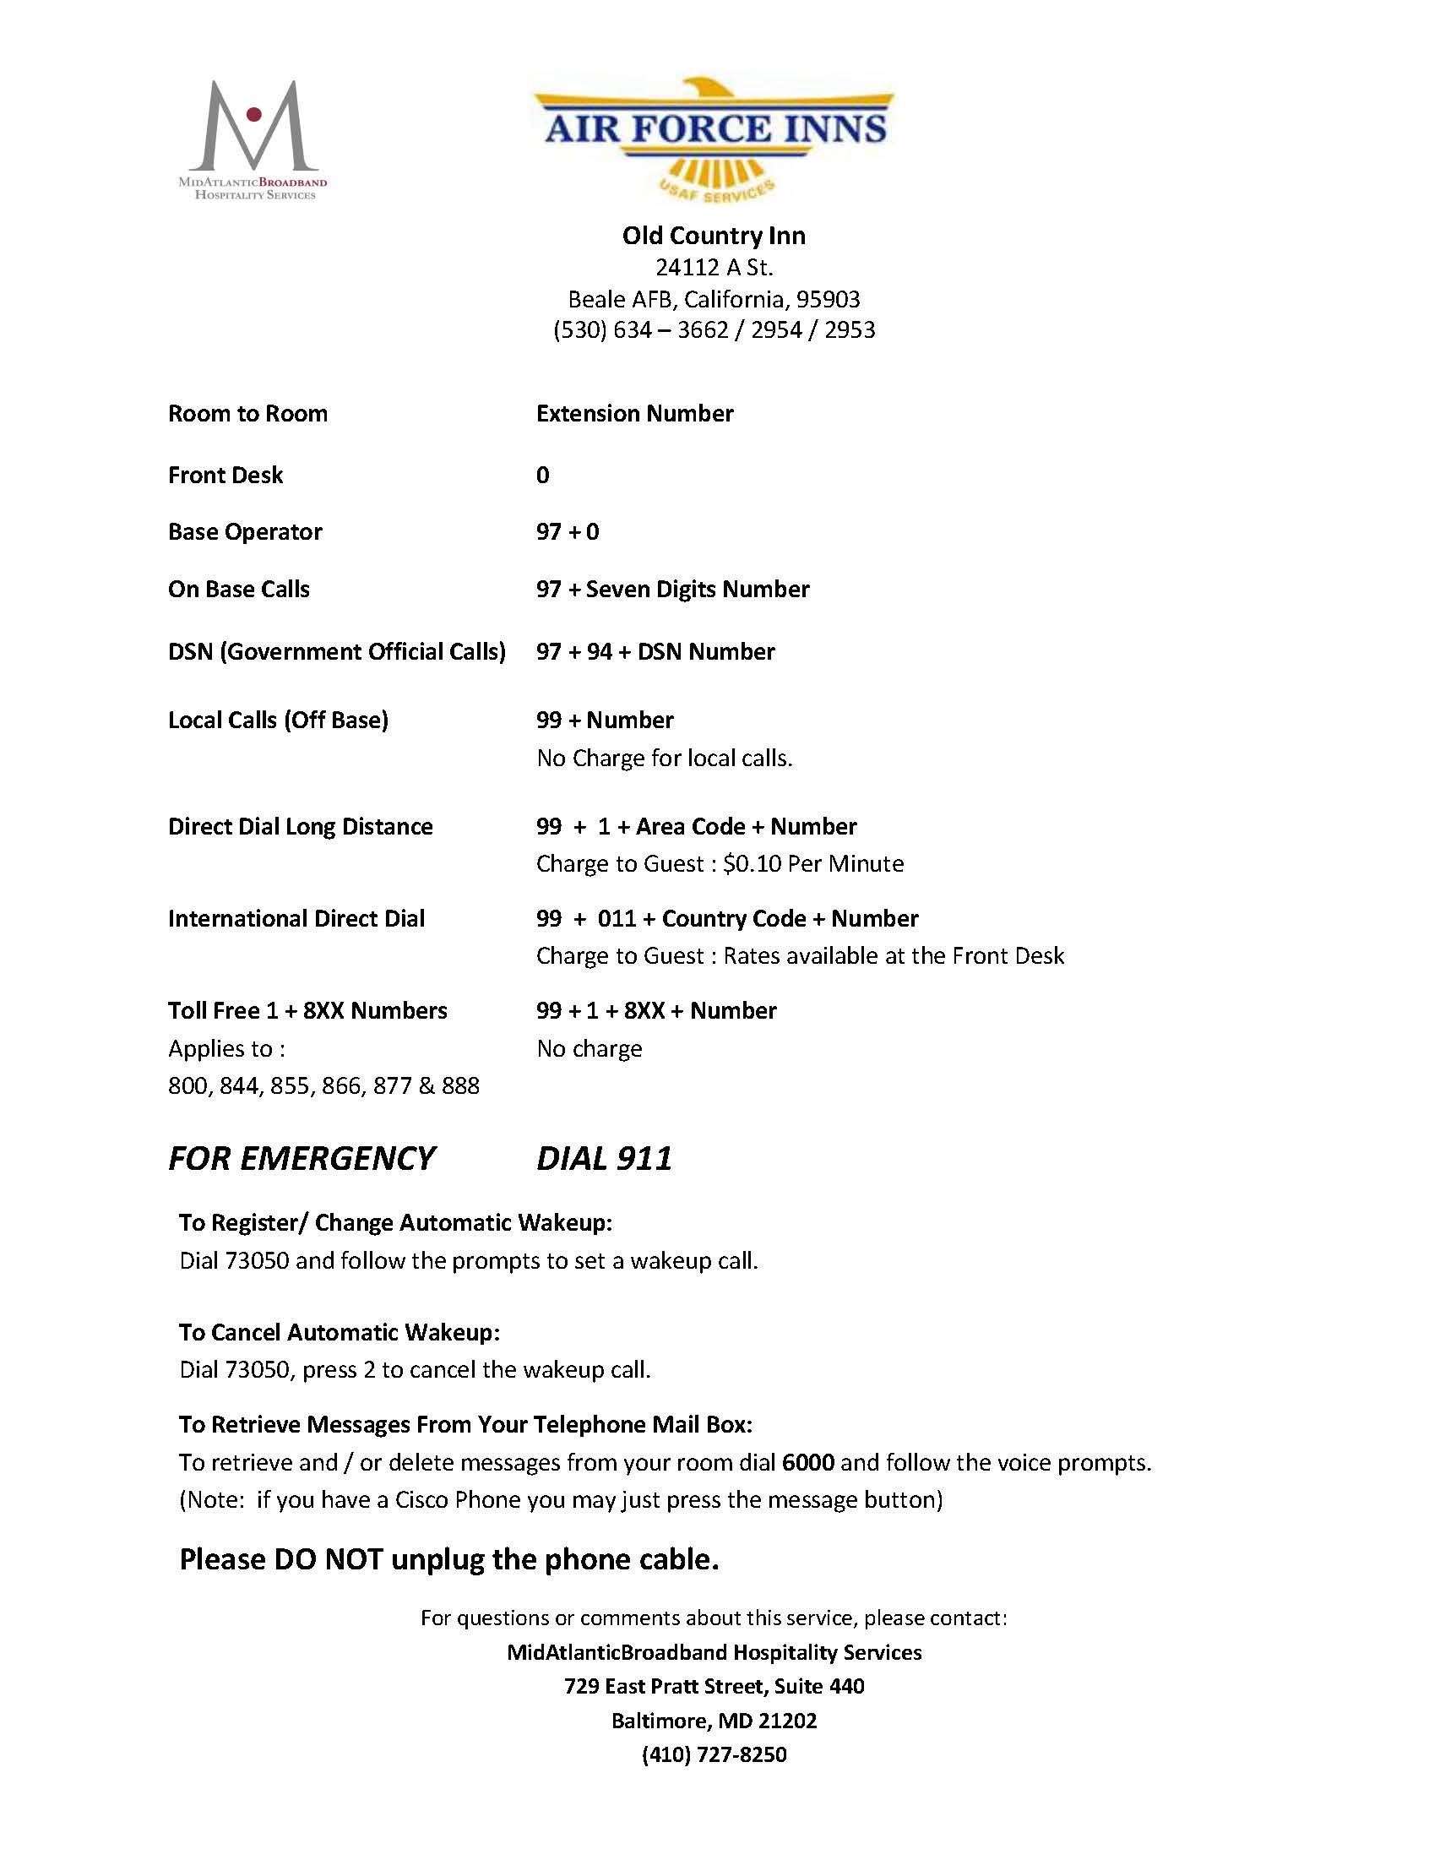

**Quick Reference List on Base**

**AAFES/BASE EXCHANGE (BX)**

Main Store (530)788-0221

Alternations (530)788-7157

Dry Cleaners (530)788-2000

Barber Shop (530)634-3437

Beale Beauty Salon (530)788-0053

Shoppette (Housing) (530)788-1271

Burger King (530)788-2517

Subway (Housing) (530)788-7628

**Food Court**

Yummy Tummy (530)788-1320

Missy’s (Coffee Shop) (530)788-0105

Hefty Gyros (530)788-1320

**COMMISSARY**

Main Office (530)634-2422

**DINING ESTABLISHMENT**

Contrails (530)634-2537

Moos and Brews (530)364-0936

Ramoneda Grill (530)634-2537

Recce Point Club (530)634-2833

Spare Time Grill (530)634-2304

Runaway Pizzeria 24/7 (530)329-8520

**EDUCATION & FAMILY**

Airman & Family Readiness (530)634-2863

Child Development Center (530)634-4717

Hub Zemke Library (530)634-2314

Education Center (530)634-2525

Youth Center (530)634-4953

**POOLS**

Main Base (530)634-2262

Lake House (530)634-5797

**COMMUNITY SERVICES**

Aero Club (530)634-9011

Arts & Crafts (530)634-2294

Auto Hobby Shop (530)634-2296

Beale Lanes (530)634-2299

Community Center (530)634-3140

Golf Course (530)788-0192

OMNI Fitness Center (530)634-2258

Outdoor Adventure (530)634-2054

Rod & Gun Club (530)788-2473

**GENERAL**

Housing Office (530)634-2793/2972

ID Cards (530)634-3187

Law Enforcement (530)634-2131

Legal Office (530)634-2928

Marketing (530)634-5407

Outbound Assignment (530)634-4005

Post Office (530)788-2401

Sato Travel (530)634-2940

**GATES**

Doolittle (530)634-9099

Grass Valley (530)634-4947

Main Gate (Closed) (530)634-9141

Vassar Lake (530)634-4709

Wheatland (530)634-2006

**CHAPELS**

Foothills Chapel (530)634-4700/4701

(Housing)

Valley Chapel (530)634-4705

(Main Base)

**CLINIC**

Clinic Appointment Line (530)634-2941

Veterinary Clinic (530)634-2104

**Base Facilities**

**Aero Club Flight Training**

1232 Arnold St

(530) 634 – 9011

*Hours: 0900-1400 (Mon-Thu)*

*Members: 24/7*

Fly with an instructor and take the first step to becoming a pilot.

**Airman and Family Readiness Center**

17800 B St

(530) 634-2863

*Hours: 0730-1630 (Mon,Tue,Thu,Fri)*

*0730-1330 (Wed)*

*Closed weekends/holidays/fam. days*

The Airman and Family Readiness Center serves as a one stop information and referral center for single, married, active duty, guard, reserved and retired members as well as their families. One of its major function linkage, ensuring military personnel and their families are connected with the appropriate services and off base.

**Arts and Craft Center**

17651 Warren Shingle Rd

(530)634-2294

*Hours: 0900-1600 (Tue-Fri)*

*Closed holidays/family days*

The Arts and Craft Center combines instructional and self-paced craft making with a wide variety of resale products to help meet the needs of customers.

**Beale Lanes Bowling Center**

17800 Robert Nicoletti Way

(530) 634 - 2299/2344

*Hours: 1300-1900 (Wed-Thu)*

*1300-2100 (Fri-Sat)*

*Closed Sundays/holidays/fam. days*

Beale Lanes Bowling offers many different ways for individuals and families to have fun.

**Auto Hobby Center**

17651 Warren Shingle Road

(530) 634 – 2296

*Hours: 0700-1600 (Mon-Fri)*

*0900-1700 (Fri)*

*Closed Sundays/holidays/fam. days*

The Beale Auto Hobby Shop is certified Napa Care Center 12,000/12 month’s nationwide warranty on repair work, excluding body work.

**Child/Youth Resource Center**

5190 Camp Beale Hwy, Bldg. 3308

(530) 634-4418

*Hours: 0900-1500 (Mon-Fri)*

*Closed weekends/holidays/fam. days*

**Community Activity Center**

17700 Robert Nicolleti Way

(530) 634-3140

*Hours: 1200-2000 (Mon-Fri)*

*1200-1800 (Weekends)*

*Closed holidays*

**Education Center**

*17849 16th Street*

*(530) 634-2525/2529*

*Hours: 0800-1500 (Mon-Fri)*

*Closed weekends/holidays/fam. days*

**FamCamp**

220 Cedar Lane

(530) 634-3382

*Hours: 0900-1200 & 1300-1630 (Mon-Fri)*

*0900-1200 (Sat)*

*Closed Sundays/holidays/fam. days*

**The Foothills Chapel:**

15001 Camp Beale Highway (Housing)

(530)634-4701

*Contact chapel staff for hours of operations*

**Base Facilities**

**Rod & Gun Club**

7950 D Street

(530) 788 – 2473

*Hours: 0900-1600 (Mon-Fri)*

*Closed weekends/holidays/fam. days*

The Beale Rod-N-Gun Club offers two skeet fields, on trap range & a 50 yard small arms range which will accommodate all small bore weapons.

**Family Child Care**

5190 Camp Beale Hwy, Bldg. 3308

(530) 812-3117

*Hours: By appointment (Mon-Fri)*

*Closed weekends/holidays/fam. days*

FCC programs consist of in home care provided by licensed and affiliated providers. Trained FCC providers are available daily, night, weekend and unusual hours of care for children 2 weeks to 12 years of age.

**Outdoor Adventure Center**

17630 Doolittle Drive

(530) 634 – 2054

*Hours: 0900-1700 (Mon-Fri)*

*0900-1300 (Sat/family days)*

*Closed Sundays/holidays*

Whether you’re interested in fishing, hiking or camping, The Outdoor Adventure Center offers you the key to California.

**Harris Fitness Center**

2418 B Street

(530) 634 – 2258

*Hours: 0500-2200 (Mon-Fri)*

*0800-1700 (wkds/hol/fam. days)*

Impressive selection of free weight and cardiovascular equipment at no fee. The center also offers personal fitness training, aerobics classes, special classes and programs.

**Recce Point Club**

17440 Warren Shingle Rd

(530) 634 – 4948

*Office hours: 0730-1630 (Mon-Fri)*

*Closed wkds/hol/fam. days*

Reece Point Club maintains the traditions of clubs worldwide while offering excellent food and beverages with reasonable prices.

**Hub Zemke Library**

17849 15th Street

(530) 634 - 2314

The library provides quality of life support, mission support to base and tenant organizations and also support education.

**Information Tickets and Travel**

17700 Robert Nicolleti Way

(530) 634 – 4882

*Hours: 1200-1700 (Mon-Fri)*

*Closed weekends/holidays*

Information Tickets and Travel Office offers loads of fantastic tours and ticket discounts.

**Youth Center**

15160 Gavin Mandery

(530) 634 – 4953

*Hours: 0615-1800 (Mon-Fri)*

*Closed weekends/holidays/fam. days*

The Youth Program provides school age programs, year round sport programs, instructional classes, babysitting certification, social recreation, dances and filed trips.

**Independence Cinema**

25th St Bldg. # 2474

(530) 634 - 3140/3165

*Hours: Call staff for hours of operation*

Independence Cinema is a movie theatre open to all base personnel. Movies are free and concessions will be available for purchase throughout the movie.

**On Base Dining 9th Force Support Squadron**

**Contrails**

Hours of Operations:

Simply to Go: 0530-1900 (Mon-Fri)

0730-1830 (Wkd/hol/fam. day)

Breakfast 0530-0800 (Mon-Fri)

0730-0900 (Wkd/hol/fam. day)

Lunch 1030-1330 (Daily)

Dinner 1630-1900 (Mon-Fri)

1630-1830 (Wkd/hol/fam. day)

Midnight 2330-0030 (Daily)

*Featuring: Breakfast made to order, continental breakfast, entrees, UFood Grill, Substation, Global Action, Simply to Go, soup and salad bar*

**Moos and Brews**

17440 Warren Shingle Rd

(530) 634-0936

**Bar Hours:**

1100-1900 (Wed/Thu/Sun)

1100-2100 (Fri/Sat)

**Dining Hours:**

1100-1900 (Wed-Sun)

Closed Mon/Tue/Holidays

*Featuring: Pizzas, appetizers, burgers, salads and daily entrée special*

**Ramoneda Grill at the Flightline**

Hours of Operations:

Monday-Friday : 0630-1300

*Featuring: Breakfast made to order, continental breakfast, Aspretto Coffee, entrees, grill, action, Simply to Go, soup and salad bar*

**Reece Point Club**

Hours of Operations:

Monday-Saturday : 0700-2200

(Varies on events)

*Featuring: The Flavor’s Catering program menu includes themed buffets, party packages and snacks for break times. Customers will also find fun and familiar favorites like nachos, wings, hot dogs, hoagies and snacks*

**SpareTime, Beale Lanes Bowling Center**

**Hours of Operations:**

Monday & Friday : 0630-2000

Saturday : 1200-2000

Sunday/Holidays : Closed

*Featuring: Fresh hand formed burgers served on house baked buns, salads, baked potato bar and pizza, full service breakfast Monday – Friday.

**Base Maps**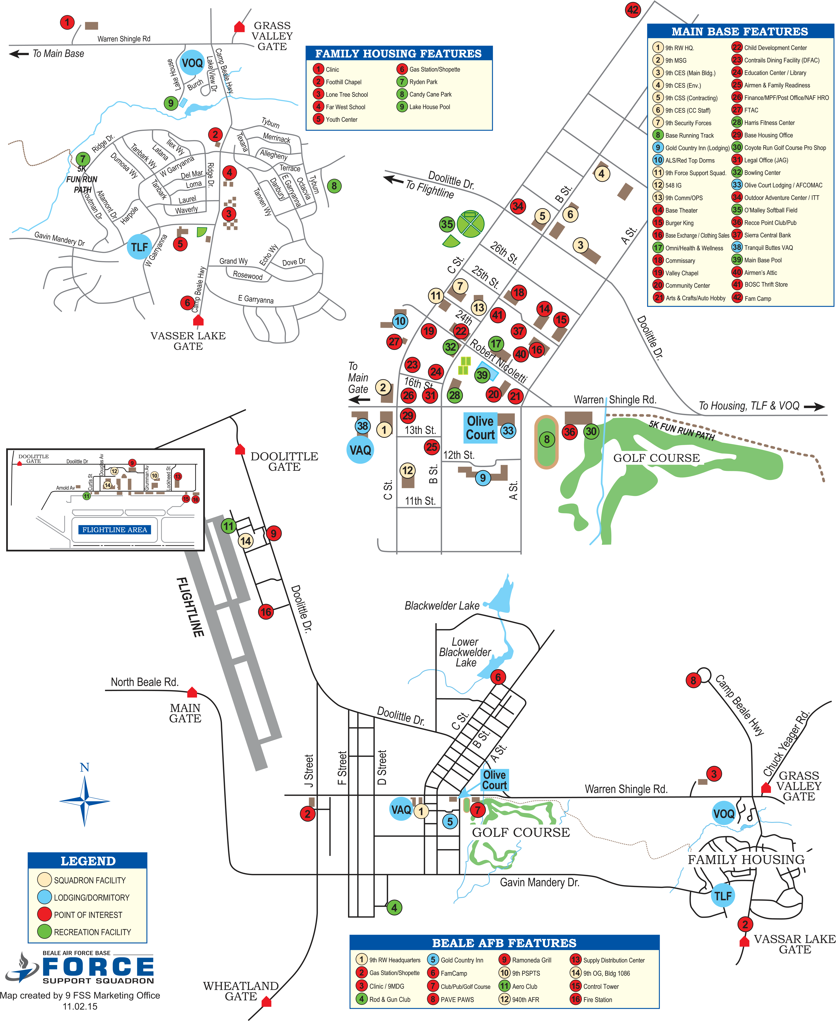

**Running Trail Map**

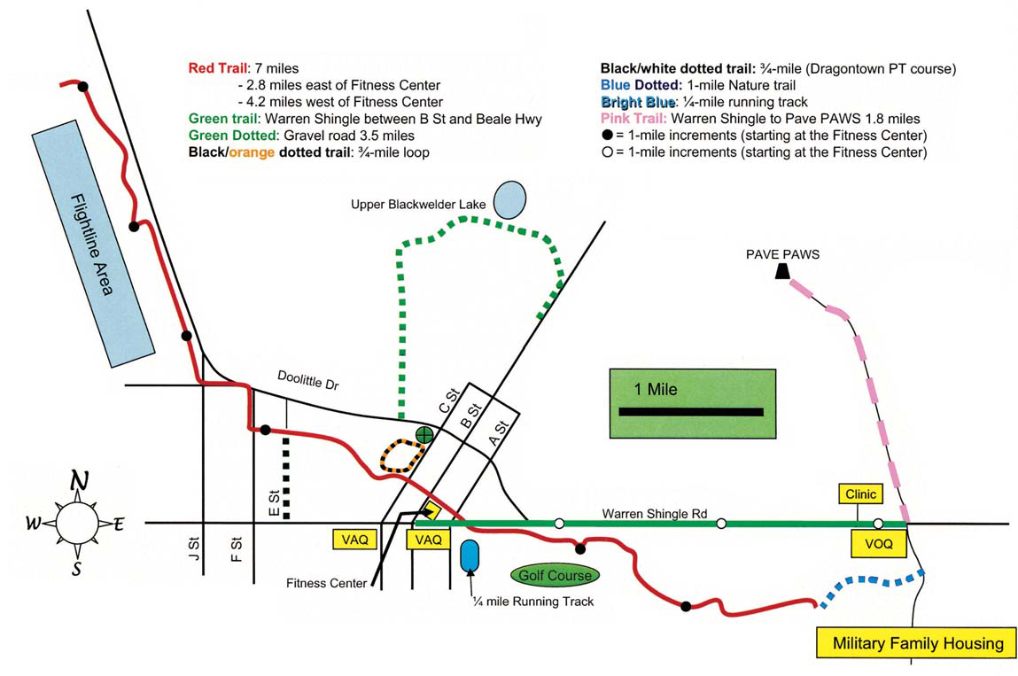

**Off Base Dining**

**Applebee’s**

1000 Tharp Rd, Yuba City

(530)822-9566

**BJ’s Restaurant**

1200 Roseville Pkwy, Roseville

(916)580-2100

**Claim Jumper’s**

250 Harding Blvd, Roseville

(916)788-1705

**Denny’s (24 Hours)**

630 10 Street, Marysville

(530)674-7710

**Hometown Buffett**

998 N Walton Ave,

Yuba City

(530)674-7710

**IHOP**

1310 Franklin Rd,

Yuba City

(530)755-0850

**Mimi’s Café**

1104 Galleria Blvd,

Roseville

(916)780-2646

**Cheesecake Factory**

1151 Galleria Blvd, Roseville

(916)781-3399

**Wingstop**

1707 Colusa Hwy Ste 100,

Yuba City

(530)671-9464

**China Moon**

315 3rd St, Marysville

(530)743-2205

**China Garden**

1590 North Beale Rd, Marysville

(530)743-2899

**Dragon Inn**

1016 G St, Marysville

(530)742-6923

**Sushi Ichiban**

1560 Butte House Rd

Yuba City

(530)751-7478

**Mongolian BBQ**

1212 Colusa Avenue

Yuba City

(530)674-8909

**Mikuni Japanese and Sushi Bar**

1565 Eureka Rd #1A

Roseville

(916)797-2112

**Mikuni Kaizen Japanese Restaurant & Sushi**

Fountains at Roseville 1017 Galleria Blvd #160

(916)780-2119

**Panda Express**

902 E St, Marysville

(530)742-1849

**Iron Grill Korean BBQ**

2030 Douglas Blvd

Roseville

(916)899-5448

**Buca Di Beppo**

1212 Galleria Blvd

Roseville

(916)771-9463

**Dancing Tomato**

990 N Walton Ave,

Yuba City

(530)790-0300

**String Italian Café**

1185 Colusa Ave

Yuba City

(530)673-7881

**Olive Garden**

1160 Galleria Blvd

Roseville

(916)783-6005

**Casa Lupe**

655 Onstott Rd

Yuba City

(530)673-2190

**Chipotle Mexican Grill**

1005 Gray Ave

Yuba City

(530)671-1581

**Chevy’s Fresh Mex**

6604 Lonetree Blvd

Roseville

(916)773-2554

**Chipotle Mexican Grill**

1005 Gray Ave, Yuba City

(530)671-1581

**El Zarape Restaurant**

1005 Stafford Way

Yuba City

(530)755-2888

**Off Base Dining**

**Domino’s**

5999 Lindhurst Ave

Marysville

(530)741-3030

**John Incredible Pizza**

384 N Sunrise Ave

Roseville

(916)772-1111

**Primetime Pizza**

1920 State Hwy 65 #170

Wheatland

(530)633-4488

**Roundtable Pizza**

828 Gray Avenue

Yuba City

(530)671-3675

**Smashburger**

Ridge at Creekside

1210 Roseville Pkwy #100

Roseville

(916)791-3100

**Islands**

**Beachy Gourmet Burger**

1902 Taylor Rd

Roseville

(916)772-5044

**Krush Burger**

Westfield Galleria at Roseville

1151 Galleria Blvd

Roseville

(855)578-7403

**The Habit Burger Grill**

933 Pleasant Grove Blvd

Roseville

(916)791-5292

**Cattleman’s**

2000 Taylor Rd

Roseville

(916)782-5587

**Outback Steakhouse**

181 North Sunrise Ave

Roseville

(916)787-9220

**Cool Hand Luke’s Steakhouse**

1669 Colusa Hwy

Yuba City

(530)822-9900

**Ruth’s Chris Steak House**

Westfield Galleria at Roseville

1185 Galleria Blvd P-120

Roseville

(916)780-6910

**Tahoe Joe’s Famous Steakhouse**

1905 Taylor Rd

Roseville

(916)797-9220

**McCormick & Schmick’s**

**Seafood & Steaks**

Fountains at Roseville

1194 Roseville Pkwy, Roseville

(916)960-4875

**Local Area Information’s**

**MARYSVILLE**

***Ellis Lake***, located in the center of Marysville has several picnic areas, fishing, paddle boat rentals and gazebo for special events.

***Beckwourth Riverfront Park*,** is located on the Feather River, the main road trough it is Bizz Johnson Drive, which can be reached

From F St or from 14th St. The park complex features free boat, softball fields, soccer fields, a golf range, a motocross and ATV

Course for off road vehicles, a BMX track, restroom and a nature area. Jet skiing and water skiing are permitted.

***Bok Kai Temple***, is a traditional Chinese temple located at the corner of D and First Streets and served as the center of what was

a bustling Chinatown for a small town.

**YUBA CITY**

***Community Memorial Museum of Sutter County,*** established in 1975 is the showplace and storehouse for many Sutter

County history treasures and memories. The museum located on 1333 Butte House Rd.

***Yuba Sutter Fairgrounds***, located in the corner of Franklin St & Wilbur Ave. The Yuba Sutter Fair is held every summer and

Other festivities are held there.

***Sam Brannan Park****,* has a public swimming pool, playground, and tennis court and picnic facilities. Located at 806 Gray Ave

**NEVADA CITY, GRASS VALLEY**

Two cities that have Victorian neighborhoods colored with giant maple and liquid amber trees in fall. For more information, please call Nevada City, Grass Valley County at 1800.655.4667

**WHEATLAND**

Toyota Amphitheatre is an outdoor amphitheater, located near Plumas Lake and Wheatland at 2677 Forty Mile Rd

**SACRAMENTO**

***California State Capitol***, located on 10th and L Street.

***Sacramento Zoo***, located at 3930 W Land Park Dr.

***Powerhouse Science Center***, Discovery Campus, Interactive, kid-friendly natural history museum featuring exhibits, after school and summer programs. Located on 3615 Auburn Blvd.

***Golden 1 Center*,** Sacramento multipurpose arena, world class Entertainment and Sport Center and located on 500 David J Stern Walk.

**\*SHOPPING**

***Yuba Sutter Mall***, 1215 Colusa Ave, Yuba City

***Westfield Galleria***, 1151 Galleria Blvd, Roseville

***Arden Fair Shopping Center***, 1689 Arden Way, Sacramento

**Local Area Information**

**SAN FRANCISCO & SURRONDING AREA**

***Pier 39*,** Bustling bayside pier featuring scenic views, sea lion sightings, eateries, shops & entertainment. Located on Beach Street & The Embarcadero.

***San Francisco Zoo***, 100 acre zoo located in the southwestern corner of SF, between Lake Merced and the Pacific Ocean along the Great Highway. Located on Sloat Blvd.

***Golden Gate Bridge*,** is a suspension bridge spanning the Golden Gate strait, the one mile wide, three mile long channel between San Francisco Bay and the Pacific Ocean.

***Alcatraz Island*,** is located in the SF Bay, 1.25 miles offshore from San Francisco.

***Alcatraz Federal Penitentiary***, was a maximum high security federal prison which operated from 1934-1963. Located on Pier 33 Concourse.

***Madame Tussauds*** is a wax museum located in Fisherman’s Wharf. The attraction opened on June 26 2014 and became the 17th Madame Tussauds museum to open worldwide. Located on 145 Jefferson ST.

**VALLEJO**

***Six Flag Discovery Kingdom****,* is 135 acre animal theme park located in 1001 Fairgrounds Dr.

**TAHOE**

***Lake Tahoe*,** is alarge freshwater lake in the Sierra Nevada, Lake Tahoe is the largest alpine lake in North America and it offers something for everyone including skiing, snowmobiling, ice skating, mountain biking, hiking and much more.

**\*NEARBY CASINOS**

***Casino Marysville***, informal locale featuring poker, blackjack and other card games plus an adjacent restaurant & lounge. Located on 514 4th St.

***Colusa Casino Resort*,** showcasing over 1,200 slot machines, a wide variety of poker and table games, and the highest Bingo payouts around. Featuring signature dishes prepared by award winning chefs, luxurious AAA diamond rated hotel and spa and exclusive outdoor adventures. Located on 3770 CA-45 and more information please, call 530.458.8844

***Feather Falls Casino*,** casino complex offering a variety of games, a buffet and brewpub, live entertainment and lodging. Located on 3 Alverda Dr, Oroville.

***Thunder Valley Casino***, the Casino has over 3000 slot and video machines, 125 table games (including blackjack and paigow) and a live poker room with enough space for 160 players. Located on 1200 Athens Ave, Lincoln.

**Commercial Transportation**

**CAR RENTALS**

**Enterprise Rent-A-Car**

911 Gray Ave, Yuba City

(530)673-7711

**Hertz**

338 Garden Hwy, Yuba City

**TAXI SERVICE**

**Super Shuttle**,

Airport Shuttle Service, Sacramento

(916)648-2500

www.supershuttle.com

(530)671-8470 **UBER & LYFT**

Are welcome on base; Customers must notify Security Forces at the appropriate gate prior to the Uber/Lfyt driver pick up

**On Base Transportation**

There is a base shuttle bus, which runs regularly 0600 to 0700, 1000 to 1100, noon to 1300 and 1500 to 1600. Monday through Friday, between 730 and 930 or 1330 and 1430. For more information please, call (530)634-2542/43.

**Airports**

Sacramento International Airport (SMF) – 44 Miles

6900 Airport Blvd, Sacramento CA 95837. Telephone number (916)929-5411

[www.sacramento.aero/smf](http://www.sacramento.aero/smf).

San Francisco International Airport (SMO) – 64 Miles

San Francisco, CA 94128. Telephone number (650)821-8211

[www.flyso.com](http://www.flyso.com)

Oakland International Airport (OAK) – 56 Miles

1 Airport Dr, Oakland CA 94621. Telephone number (510)563-3300

[www.oaklandairport.com](http://www.oaklandairport.com)